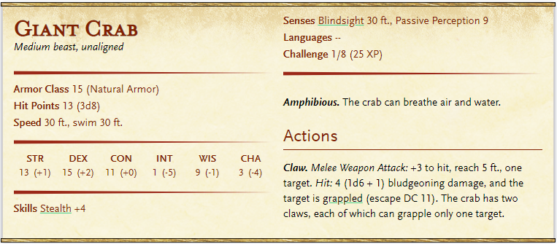**Monsters – Beyond the deep forest**

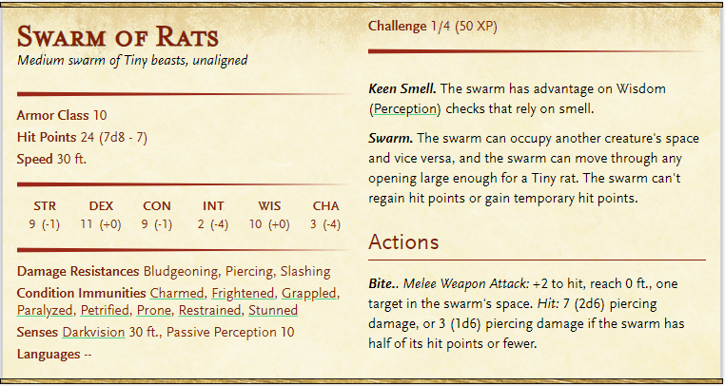**Swarm of Crabs**

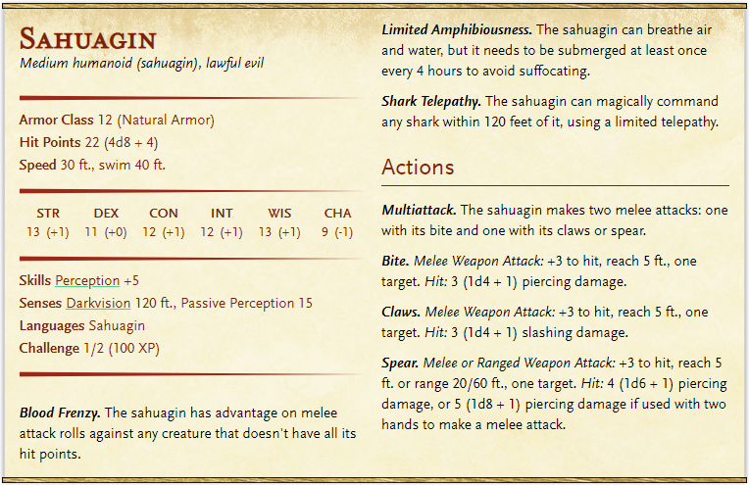1 Bronze crown (250GP), 2 raw fish, Weed necklace, 15 Teeth of a shark.

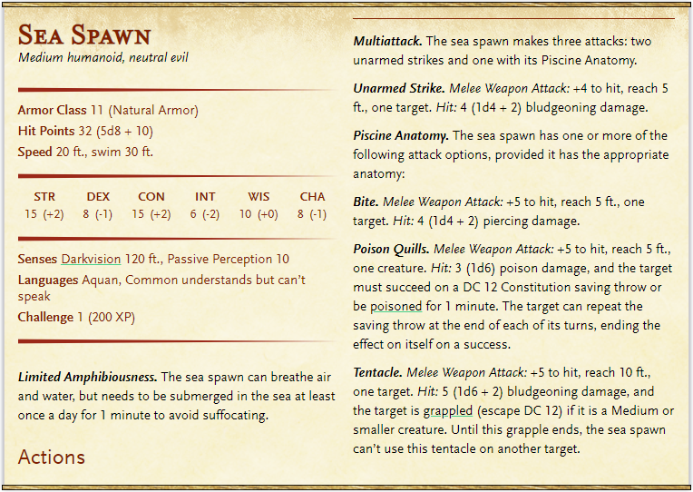

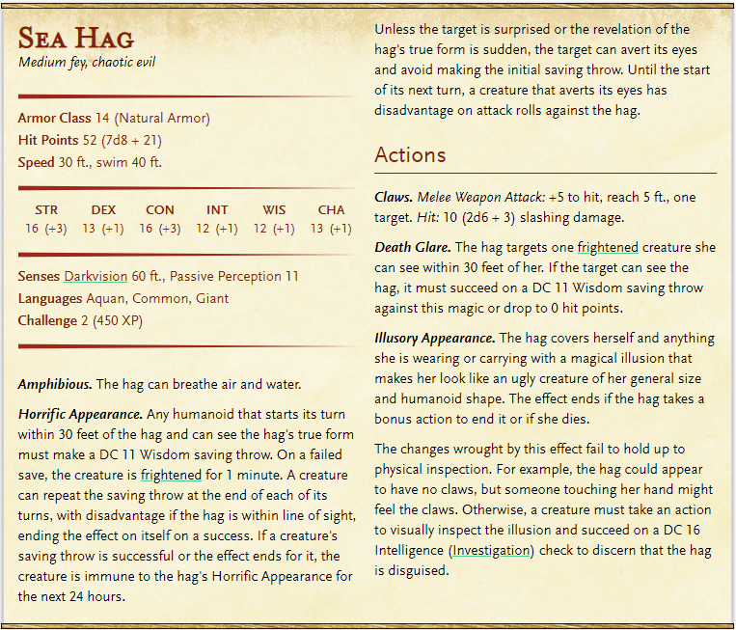

1 Puppy of a White Dire wolf (*MM321*), (use statistics of a cat *MM320*)

Perfume of bewitching (*XGtE138),* Wand of conducting *(XGtE140)*

170GP + 200CP + 1 jade gemstone (100GP – translucent light green) + Gold Dragon comb set with red garments as eyes (750 art object) + Dresses of many colors and sizes, and many suits, and highly decorated clothes.

Drugs: 3 vials of Mud, 3 vials of Snowflake, 4 vials of Ozz, 1 vial of Eyener.

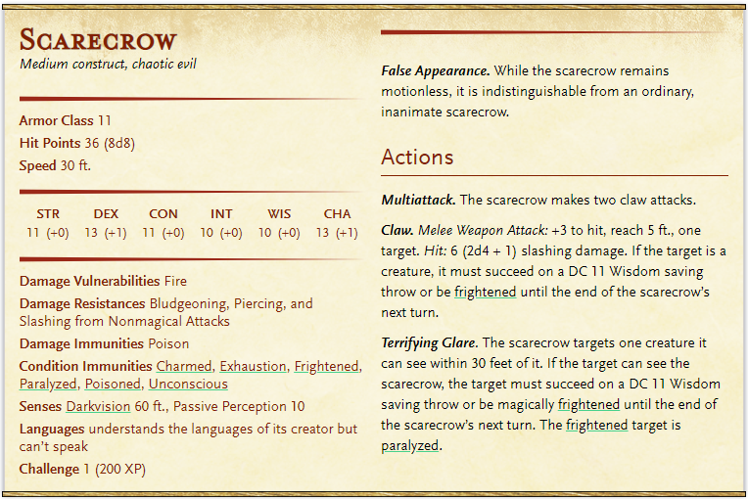

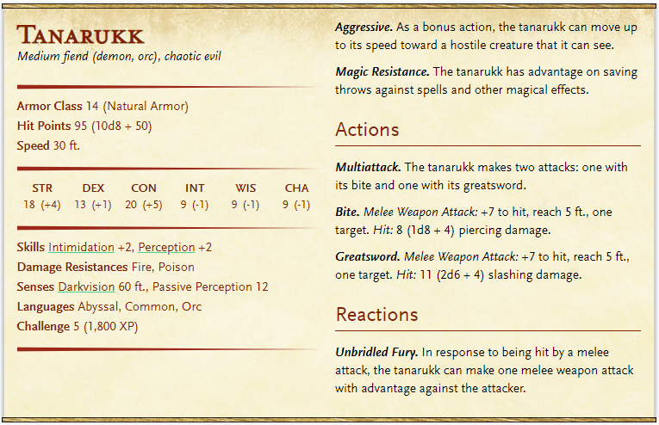Encounter Before Mund

